A

SUMMER TRAINING REPORT

On

“COMPARATIVE ANALYSIS OF VARIOUS BROKERAGE FIRMS”

Submitted in partial fulfillment of the requirement for award of Post Graduate Diploma In Management BIMM, Pune.

Submitted
By

ASHISH LIHINE
PGDM (2011-13)
MARKETING

Of

BIMM, Pune
________________________________________
Guided
By
Mr. Neelabh Jha
Sales Manager,Edelweiss,mumbai



BALAJI INSTITUTE OF MODERN MANAGEMENT, PUNE

ACKNOWLEDGEMENT

It is my great pleasure to express my gratitude and sincere thanks to the management

Staffs of the EDELWEISS LTD, MUMBAI for giving me opportunity to undergo

Training in their organization.

I also express my gratitude towards my friends and coordinators for there cooperation.

This project would not have been completed without the guidance of our teaching

staff and project guide Mr.Neelabh Jha

I express my sincere thanks and gratitude for their kind co-operation.

(ASHISH LIHINE)

Declaration Certificate

I hereby declared that the information mentioned in the following data is true as per my knowledge and belief. My project is an authentic work carried out by me under the guidance of my guide. All the information includes here is fully unbiased and the technical aspects added here is on the basis of the guidance of my supervisor.

Date : Student name

Place : Ashish Lihine

Introduction

In this era of globalization we are witnessing innovations in financial engineering resulting in evolution of a new set of product in banning and capital. Financial market

In India is flourished with plethora of financial products to invest in. The financial engineering so far been responsible for the invention of new range of products to suit the requirement of the investors according to his or her risk taking ability. The basis purpose the project is to find out potential customers by creating awareness among themselves. Ladder of loyalty shows how a prospect gets converted into advocate. Prospect is a person who knows about the product but is not prospective for the company and advocate is a person who promotes the company and its product through word of mouth and does recommendation of company. This conversion process of prospect to advocate needs awareness program. Mumbai segment was surveyed to attain certain results. The survey was conducted to analyze the prospective customer awareness for various online services available in the market, to find out the factors which would influence the buying decision of the customer, and to find out the interest of the prospective customers in online share
trading. The research tries to find out the services offered by major players by
Comparing them on various ground and bring out there special features by method of
Desk research.

INDEX

Ch.no. | Title | Page no
 | Profile of the Organization | 6-9
 | Objective & Scope of the study | 10-11
 | Literature Review | 12-19
 | Research methodology | 20-24
 | Data analysis | 25-45
 | Findings | 46-49
 | suggestions | 50-51
 | Annexure | 52-54

Chapter 1

Profile of the Organization

Edelweiss Limited is in stock broking service for over 20 years now. Edelweiss was found and established in 1992. Since then it has focused on strengthening its presence in the rapidly expanding retail broking market. Further EBL was incorporated on November 21, 1995, it is known as composite corporate member of stock exchange Mumbai (BSE) holding two cards. Company has recently obtained SEBI registration to act as Portfolio Manager, International private equity investor like HSBC private equity India fund limited. A first Carlyle venture, maturities an Intel capital, collectively hold 44.51% of the equity capital remaining 55.46% of the equity is between promoters and 0.03% is held by the employees. EBL has its presence in the retail market since its inceptions over 20 years ago; it is on of the first introduced researches, exclusively suited for the retail investor giving recommendations. Edelweiss has 640 outlets in 280 cities in India.

Current Focus Priorities

Services “institutional investor – domestic / international”, with the strong settlement system and extensive use of computerization EBL has build up one of the largest retail broking business in India. Its retail broking services are customized to effectively address the needs of the corporate clients, high network individual, as also retail investors, with effective solutions tailor made to the requirement of each category of client.

Expertise in
Research coverage – active coverage of political development of economy changes. Sector wise investment strategies are in place. Stock ideal are taken out from time to time, in tune with overall strategies. Total coverage also includes the GDR stocks. Companies institutional research team is rated as one of the best in the industry resulting in the 5% market share of all foreign institutional portfolio investment and 5% market share for all domestic client of Edelweiss provides online trading facilities for its client for which clients are supposed to open an account with Edelweiss.in Edelweiss has three kind of accounts to suit the trading habit of clients viz
- Classic account – This account allows the client to through Edelweiss’s website and is suitable for retail investors. Edelweiss’s online trading website also comes with a dial-n-trade service that enables customer to buy and sell shares by calling toll free number.
- Speed trade and speed trade plus account – These are the state of the art web trading products ideal for active traders and jobbers who transact frequently during the day’s trading session to capitalize on intra day price movements. Speed trade gives active traders and jobbers the edge with real time access to the market.

Key features of speed trade and speed trade plus:
- Single screen trading terminal
- Real time streaming quotes
- Live tic by tic intra day charting
- Instant order/ trade confirmation in the same window
- Hot keys similar to a brokers terminal
- Customized alerts based on multiple parameters
- Back up facility to place trades on direct phone lines
Terms and conditions

PARTICULARS | CLASSIC A/C | SPEEDTRADE A/C | SPEED TRADE PLUS A/C
One time registration fee | Rs. 49 | Rs.2000 | Rs.6000
A/c maintenance charges | Nil for 1st year and Rs.300/annum form 2nd year. | Nil for 1st year and Rs.300/annum form 2nd year | Nil for 1st year and Rs.300/annum form 2nd year.

Brokerage Structure:-
Intraday trading: 0.1%
Delivery : 0.5%
Exposure : 4 times of the deposit.

Services provided by Edelweiss Ltd

6 Verticals for any kind of transactional requirement

One of the largest equity desks. Leadership in derivatives
Services across 38 locations
Largest range of products
Life-cycle financial solutions
Unparalleled range of advisory services
Maximum risk adjusted returns
Leading Fire & Auto insurance advisory
Differentiated research
Thematic and long-term
Edelweiss
Investment Banking

Institutional Equities
Private Client Services
Wealth Management
Asset Management
Insurance Advisory
Research & Analytics

Mission Statement of the Company: “Ideas create, values protect”
Company’s Objective: To increase market share of the company as well as to increase customer’s satisfaction level

The structure of company

The structure of company can be diagrammatically presented as below:-
Managing Director
Zonal Manager
Zonal Manager
Zonal Manager
Zonal Manager
Regional Manager
Regional manager
Regional manager
Regional Manager
Branch Manager
Branch Manager
Branch Manager
Branch Manager
Ass. Sales Manager Manager
Ass.Sales Manager
Ass. Sales Manager
Ass. Sales Manager

Sale’s Executives

Sale’s Executives

Trainees

Trainees

Chapter 2
Objectives & Scope of the Study

Online share trading is not a new concept for India too. NSE has started it in 1992. Still share-trading is not very popular among middle class people and they think it as risky investment. If we see the growth of the Sensex .It has increased more than 15 times in 16 years. In 1992 it was at just 1000 and today it is about 15000. It was at 21000 in January 2008.
During research it was my aim to find out different aspects of online trading and people’s interest about it . Which companies are popular among them, how much they know about these things, how much are they satisfied etc.?
Meanwhile I was also looking for prospect customers also for Edelweiss Ltd. Followings are the main objective of the research:

Primary Objectives:

- To find out potential customer by creating awareness among the people for
Opening Demat a/c
- To find out the customer’s perception and expectations about the company and its products and services.
- To collect data regarding the performance of the company in the market.
- To determine the major competitors in the market.
- To know which share trading service provider has maximum customers.
- To identify satisfaction level of the customers.
- To study the awareness and interest of customers for online trading services.
- To find out customer’s satisfaction level.

Scope of the study

- To find out customer’s overall perception about the system.
- To know what motivates prospective customer to think about going for online share trading.
- To know what options are used by customer in online trading.
- To get information regarding the current market share of the company.
- To know competitors of Edelweiss in the market.
- To improve the efficiency of the staff and services of the company.
- To increase the Value proposition of the organization.
- This project is basically done to enhance the market share of the company

Chapter 3

Literature Review

Bringing together under one site all the relevant factors to enable an informed investment is what online trading is all about. There are several terms which are commonly used for online share trading :

1. De-Mat A/c – This is a account where dematerialization takes place. Dematerialization is the process by which physical certificates of an investor are converted to an equivalent number of securities form and credited into the investor’s account with his/her DP.

2. DP – A depository participant is an agent of the depository through which it interfaces with the investor. DP can offer depository services only it gets proper registration from SEBI.

3. Depository – A depository is an organization which holds securities of investor in electronic form at request at request of the investor through a registered repository participant. It also provides services related to transactions in securities.

4. Saving A/c - This is a regular bank a/c which is linked to D Mat a/c and trading a/c. required amount of money is used for trading from saving a/c.

5. Trading A/c – This is a a/c through which actual trading i.e. buying and selling takes place. In online share trading all three accounts are interlinked.

TRADING ACCOUNT

SAVING ACCOUNT

DE-MAT
ACCOUNT

6. Limit order- A price higher or lower than you wanted, you need to place a limit order rather than a market order. A limit order is an order to avoid buying or selling a stock at order to buy or sell a security at a specific price. A buy limit order can only be executed the limit price or higher. When you place a market, you can’t control the price at which your order will be filled. Remember that your limit order may never be executed because the market price may quickly surpass your limit before your order can be filled. But by using a limit order you also protect yourself from buying the stock at too high prices.

7. Market order- Market order is an order to buy or sell stock at the current market price. Unless you specify otherwise, your broker will enter your order as a market order.

8. Order- Investors have several options when it comes to placing an order to buy or sell the securities. For example, whether you place an order directly with your broker or trade online, you can instruct your broker to buy or sell at a specified price. Or you can place an order that is good for one day only or for an extended period.

9. Stop order- A stop order is an order to buy to sell a stock once the price of the stock reaches the specified price, know as stop price. When the specified price is reached, your stop order becomes a market order.
Buy stop order- Investors typically uses a stop order when buying stock to limit a loss or protect a profit on short sell. The order is entered at a stop price that is always above the current price.
Sell Stop order- A sell stop order helps the investors to avoid further losses or to protect a profit that exists if the stock price continues to drop. A stop order to sell is always placed below the current market price.
10. Short Sell- A short sell is generally the sale of a stock you do not own. Investors who sell short believe the price of the stock will fall. If the price of the stock drops, you can buy the stock at lower price and make the profit. If the price of the stock rises and you buy it back later at higher price, you will incur a loss.
Account Opening

To avail the services of depository one requires opening an account with any of the depository participants. The e-invest account is an account which allows a customer electronic trading on the exchange. Through this unique three in one trading every customer opening an e-invest account gets a bank saving account.

Client Registration Process
FORM SUBMISSION
SCRUTINY

SEGREGATE
OPEN A/C OR REJECT
BANK
VALID
FORM
INTIMATES
CPU
OPEN A/C OR REJECT
DP

Stock-market in India

Introduction:

There was a time when India was discussed as the land of snake charmers, black magic and epidemics but the revolutionary Indian growth story changed everything. Indian economy at its height compelled the world to change its viewpoint towards India. Out of the several factors which changed the face of modern India, we are going to discuss the most roaring of them i.e. our share market. The earlier reform procedures adopted by India gave India the two most sought after world-class brands i.e. SENSEX and NIFTY. The magical figures displayed by our market turned all the heads on India. And India became one of the most favored places for investment.
Now I am going to deal with the ups and downs in the share market since last two years
i.e. since year 2006.our share market has went through many phases in there 2 years. We saw the investors getting overjoyed at 21K and we saw them crying too when it crashed. We saw how the market rewarded the undervalued shares and how the overvalued shares fell down to demonstrate the saying “everything which rise more than expected, has to fall.”
So to analyze the saga of Indian share market, we had two indices to follow: BSE Sensex and NSE nifty. Though NSE nifty is a more advanced option and has left BSE Sensex far behind, still we call BSE Sensex as the barometer of our economy. That’s why I have followed the BSE Sensex. It was not possible to track each and everyday figure of the Sensex since last two years. The performance of the Sensex is analyzed with the help of data and graphs collected from various sources and some of the most talked about movements of Sensex starting with the secondary market summary of each year, firstly year 2006 and then year 2007

SENSEX during 2006: (Economic Survey 2007-08)
2006 | BSE
Jan | 9920
Feb. | 10370
Mar | 11280
Apr | 12043
May | 10399
Jun | 10609
Jul | 10744
Aug | 11699
Sep | 12454
Oct | 12962
Nov | 13696
Dec | 13787

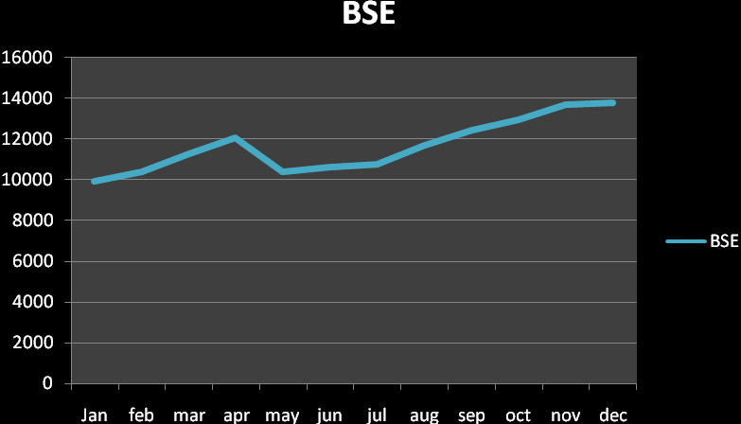

Sensex during 2007: (source: Economic Survey 2007-08)
2007 | BSE
Jan | 14091
Feb | 12938
Mar | 13072
Apr | 13872
May | 14544
Jun | 14651
Jul | 15551
Aug | 15319
Sep | 17251
Oct | 19838
Nov | 19363
Dec | 20287

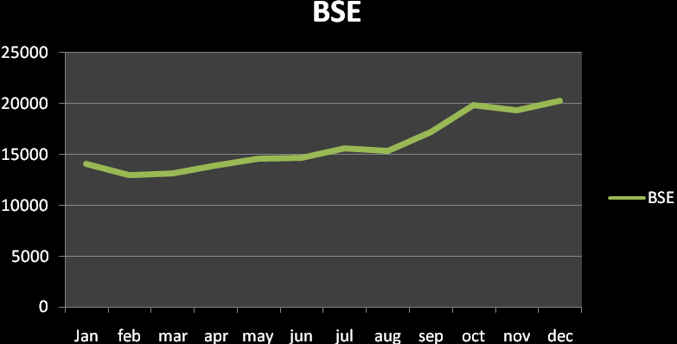
Sensex during year 2008:
After scaling new heights of 20000+, Sensex entered year 2008 with rosy pictures. The trade pundits, brokers and even investors predicted new heights for the year. And they felt their predictions coming true when Sensex touched the 21000 mark on 8th January 2008. It’s interesting if one sees in terms of flows; the journey from 20,000 to 21,000 is dominated by domestic institutional investors; FIIs were negative sellers, they sold in the cash market to the tune of USD 45 billion. So if one has to take out some pointers from this journey from 20,000 to 21,000, it is the longest journey which we have seen in the last 5,000 marks, the midcaps and small caps have been outperformers and in terms of flows, it has been domestic institutional investors which have been really putting the money.
But the rosy picture soon turned gloomy. The skyrocketing Sensex suddenly started heading south and Sensex saw the biggest absolute fall in history, shedding 2062 points intra-day. It closed at 17,605.35, down 1408.35 points or 7.4 per cent. It fell to a low of 16,951.50. The fall was triggered as a result of weakness in global markets, but the impact of the global rout was the biggest in India. The market tumbled on account of a broad based sell-off that emerged in global equity markets. Fears over the solvency of major Western banks rattled stocks in Asia and Europe.
After the worst January in the last 20 years for Indian equities, February turned out to be a flat month with the BSE Sensex down 0.4%. India finished the month as the second worst emerging market. The underperformance can partly be attributed to the fact that Indian markets outperformed global markets in the last two months of 2007and hence we were seeing the lagged impact of that outperformance. In the shorter term, developments in the US economy and US markets continued to dominate investor sentiments globally and we saw volatility move up sharply across most markets.
The Bombay Stock Exchange (BSE) Sensex fell 4.44 percent on Monday, 31st march the last day of the financial quarter, to end the quarter of March down 22.9 percent, its biggest quarterly fall since the June 1992 quarter, as reports of rising inflation and global economic slowdown dampened market sentiments. Financial stocks led the Sensex slide along with IT. According to market analysts, IT stocks fell on worries about the health of the US economy. Indian IT firms depend on the US clients for a major share of their revenues.

Conclusion:
After going through all the analysis regarding the stock market in last 2 years, we can say that stock market touched its peak at 21000 but then crashed badly. Now it is revolving around a 14000-16000 figure. Though the Sensex is a barometer and after seeing such fluctuations one could be afraid of investing. Still we can say that people can play safe by investing the blue-chips and undervalued shares.
During year 2006, if we keep aside that brief period of loss that the market witnessed from may 10 2006 to June 14 2006, investors’ wealth seem to have grown double fold with the Sensex touching the 10000, 11000, 12000, 13000 and 14000 levels in the same calendar year. Investor wealth in terms of market capitalization has been growing in the range of 6.84-12.41%
And talking about year 2007, we can summarize the happenings of year 2007 as a year which redefined the resistance levels at Sensex. Strong economic data, heavy inflow of funds from FIIs towards the close of previous calendar year and decent to highly encouraging surge in earnings of top notch companies all pointed to a rosy 2007. The rupee's rise against the US dollar the regulator's decision to restrict investments made through participatory notes, rising crude oil prices, the sub-prime mortgage woes in US, concerns over a slowing down US economy and The Left parties' opposition to the Indo-US nuclear pact, did halt the market's progress at times. But the inherent strength of the Indian economy, fairly buoyant results quarter after quarter, the various chops and subsidies announced by the government and sustained efforts made by the market regulator to keep investor confidence in the system alive kept the momentum going.
Presently the hike and seek being played by crude prices, inflation and RBI is affecting our market to a great extent. And adding to the worries are global slowdown, political instability, serial bomb blasts, negative public sentiments etc. It is indeed surprising that though the epicenter of the sub-prime crisis is the US, the tremors are being felt in India. The loss of market cap in the US is only 14 per cent vis-À-vis 38 per cent in India.
But even after analyzing the causes for downturn, we can say that India story has not ended; else $200 billion with institutional investors would have fled for safer waters. Exports being 14 per cent of GDP, India is less vulnerable to external shocks than many other Asian nations. Political uncertainties too have narrowed down.
Savings in India have risen at a historic rate of 35 per cent on the growing GDP base; 17 per cent of this is in gold, commodities and real-estate while financial savings represent 18 per cent of GDP. Even this is skewed towards deposits both banking and non-banking, while the percentage of savings in shares and debentures is a mere 6.3 per cent. If this percentage goes to 25 per cent, it would amount to $40 billion of incremental money being diverted to capital markets. So even after such downturns, we can be hopeful for a positive market.

Chapter 4

Research Methodology

Marketing research is a systematic design, collection, analysis & reporting of Data which is relevant to specific market situation .

My research process is as follows.

- DEFINES THE PROBLEM AND RESEARCH OBJECTIVES

The objective of the research conducted was to study of consumer’s preference for online share trading. Secondary objective of the survey was to know the customer’s satisfaction level. My other objectives were to find out the overall perception about the system and what motivates the people to think about going for online share trading.

(2)DEVELOPING RESEARCH PLAN
The second stage of marketing research calls for developing a most efficient plan for gathering needed information. Designing a research plan calls for taking decision on data sources research, approach, research instrument, sampling plan and contact methods.

DATA SOURCE
There are two types of methods used in data collection i.e. primary data & secondary data.

A) Primary data

Those data which are collected at first hand by the researcher especially for the purpose of the study ,are known as primary Data .The data is collected directly from the person in sample population. In this project research the collection of data is directly interviewing customer. In the collection of the primary data, I have used survey method and use the questionnaire methods.

There are mainly two methods for the collection of the primary data which are given below,

- Observational Method.
- Survey Method.

Observation Method:-
In the observation method, it requires the observer. The observer will keenly observe the person at the time of the interview & record his behavior accurately. it is also one of The important method for the collection of data but it requires good & experienced observer who can observer The behavior of the respondent properly and record it with great accuracy.

Survey Method:-
It is most popular method for the collection of necessary data from the respondents. I have used survey method for the collection of the necessary data.
Different types of the survey are given below,
- Personal interview.
- Telephonic survey.
- Mail questionnaires.

Personal Interview:-
In the personal interview, the interviewer will personally meet the respondent and will take is interview. The interviewer will ask question in face to face direction to the respondents or group of respondents.

Telephonic Survey:-
In the telephonic interview, the interviewer will make call to respondents, inform the respondents about the purpose of the call and then he will ask the related questions to the respondents. This method is used, when the information to be collected is limited. It is mostly used when information to be collected is limited.

Mail Questionnaire:-
In the mail questioner the interviewer will mail the questionnaire to the respondents and inform them about the purpose of the survey. Also the time limit for the questionnaire is specified in the mail. This method is used when the area to be covered is large and the survey has to be conducted in the specific limit.

In my survey, I have used the personal interview to know customer awareness towards online share trading. I have visited respondents personally.

B) Secondary Data
Any data which had been gathered earlier for other purposes are secondary data in hand of marketing research. These data has been collected from company dealer like Dealer profile, industrial profile, company profile are collected from the internet.
The secondary data are collected from the magazines, internet and
Web -sites. Different web sites like www.Edelweiss.com and GOOGLE
Search engine help in collecting the detailed information.

RESEARCH APPROACH

Out of 4 ways of research approaches i.e.
1. Observation research.
2. Survey Research
3. Focus Group research
4. Experimental research.
In this project the approach used was survey approach because the main objective of our survey was to study of the market potential and have an idea about the customer awareness.

Sampling Research instruments can be of two types firstly questionnaire methods and secondly mechanical instruments. In this survey the research instrument was questionnaire method.

Sampling Plan:-
Sampling size : 50
Field Work area : Mumbai City
Random sampling

Sampling Procedure:-
The sampling Procedure can be of two types:
1. Probable Samplings
2. Non-probable sampling
In this survey expert Judgments sampling method can be used.

Contact Methods:

The method of contacts can be four types

1. Mail Questionnaire
2. Personal Interview
3. Telephonic Interview.
4. Internet
The survey method adopted in our survey is Personal Interview method.

Collection of Information:

The information was collected from customer by personally asking them Question and filling the Questionnaire.

Analyze The Information.

The information available is analyzed in the form of tables, graphs and pie chart.

Presentation of Findings.

Presentation of research in the company was on the basis of findings and suggestions.

STATEMENT OF PROBLEM

Problem definition is one of the most important parts of the study. It is very important to properly define the problem. If the problem is properly defined then it will provide proper guide line for the further study. The properly defined problem will direct the surveyor on the proper path. And it is truly said that a properly defined problem is a half solve.
Here the main problem is to study the CONSUMER’S PREFERENCES FOR ONLINE-TRADING (in Mumbai). Market potential is nothing but the finding out potential customers for the product of organization; which gives maximum profitability. To find out market potential study of competitors; consumer behavior; brand positioning is must which gives idea about the market scenario. Online share trading –share trading is nothing but the buying and selling shares as per the market position, this is done through broker. Broker-broker is the person who brings buyer and seller together.
So the problem is to know the market potential of online share trading and the popularity of online share trading among the people. It is also to know which options are preferred by customers.

Chapter 5
Data Analysis and Interpretations

- Investment’s Options

 |  | Frequency | Percent | Valid Percent | Cumulative Percent
 | Bank | 2 | 4.0 | 4.0 | 4.0
 | Insurance | 20 | 40.0 | 40.0 | 44.0
 | Post office | 10 | 20.0 | 20.0 | 64.0
 | Mutual-fund | 18 | 36.0 | 36.0 | 100.0
 | Total | 50 | 100.0 | 100.0

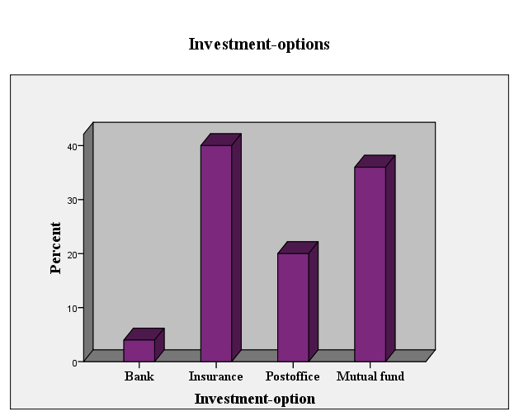

This shows that most of people, who are observed, are interested in investing in Insurance or Mutual Fund .
20% people are also interested in investing in Post office.

02. BRAND AWARENESS

Companies | No. of respondents | Percentage
ICICI | 22 | 45%
Edelweiss | 16 | 31%
Kotak Securities | 07 | 14%
HDFC Securities | 05 | 10%
Total | 50 | 100%

0%
5%
10%
15%
20%
25%
30%
35%
40%
45%
Percentage of
People
ICICI
Edelweiss
Kotak
Securities
HDFC
Securities
BRAND AWARENESS

ICICI was at the top of the mind of 45% people out of 100% and Edelweiss securing second position with 31%, followed by Kotak and HDFC with 14% and 10% respectively.

03. Is online trading easy?

 |  | Frequency | Percent | Valid Percent | Cumulative Percent
 | yes | 41 | 82.0 | 82.0 | 82.0
 | no | 9 | 18.0 | 18.0 | 100.0
 | Total | 50 | 100.0 | 100.0
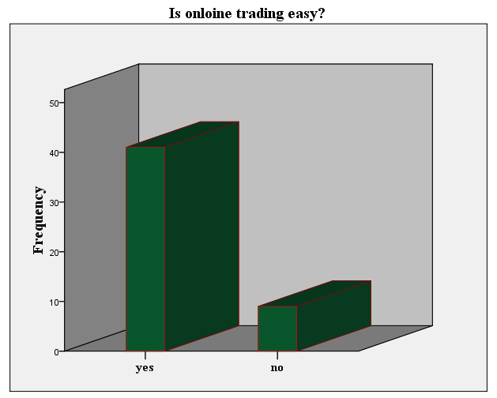

This proves most of people accept that online trading is easy. This is a plus point for stock trading companies.

04. Do you need training?

 |  | Frequency | Percent | Valid Percent | Cumulative Percent
 | yes | 42 | 84.0 | 84.0 | 84.0
 | no | 8 | 16.0 | 16.0 | 100.0
 | Total | 50 | 100.0 | 100.0
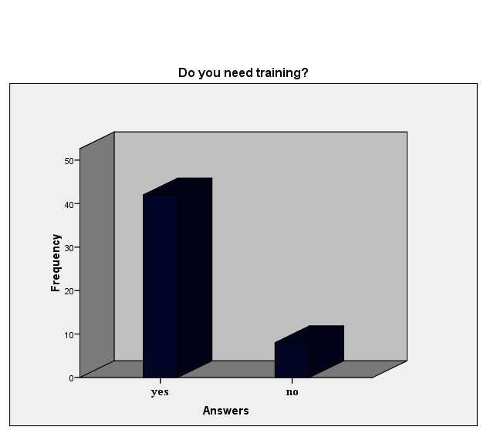
This shows that people need proper training for using online trading although it is easy.
05. SOURCES OF ADVERTISEMENT

Sources | No. of respondents | Percentage
News papers & magazines | 32 | 64%
Friends | 10 | 20%
Other media | 08 | 16%
Total | 50 | 100%

0%
10%
20%
30%
40%
50%
60%
70%
Percentage
Of people
News papers
& magazines
Friends
Other media
SOURCES OF ADVERTISEMENT

63% people come to know about online share trading through news paper and magazines whereas 20% people come to know through friends and 17% people come to know through other media like internet, news channel etc.

06. Which is better, NSE or bse?

 |  | Frequency | Percent | Valid Percent | Cumulative Percent
 | nse | 44 | 88.0 | 88.0 | 88.0
 | BSE | 6 | 12.0 | 12.0 | 100.0
 | Total | 50 | 100.0 | 100.0
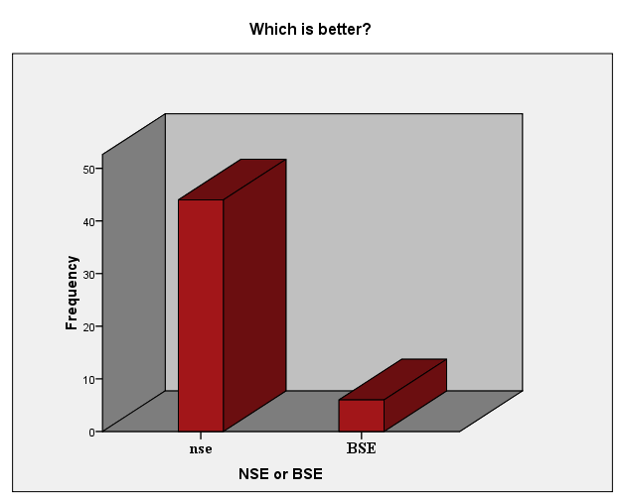

This shows that most people like NSE in comparison of BSE.

07. AWARENESS OF E-BROKING

Reply | No. of respondents | Percentage
Yes | 20 | 40%
No | 30 | 60%
Total | 50 | 100%

60% people were unfamiliar of the term e-broking and only 40% people aware were with the concept of e-broking.

08. KNOWLEDGE THROUGH COMPANY WEBSITE

Reply | No. of respondents | Percentage
Yes | 22 | 43%
No | 28 | 57%
Total | 50 | 100%

0%
10%
20%
30%
40%
50%
60%
Percentage
Of people
Yes
No
KNOWLEDGE THROUGH COMPANY WEBSITE

Out of the total sample size 43% people have visited the website of any e-broking company and 57% people have not visited any website regarding e-broking.

09. VISIT BY COMPANY REPRESENTATIVE

Reply | No. of respondents | Percentage
Yes | 12 | 24%
No | 38 | 76%
Total | 50 | 100%

0%
10%
20%
30%
40%
50%
60%
70%
80%
Percentage of
People
Yes
No
VISIT BY COMPANY REPRESENTATIVE

Only 24% people who are interested in online share trading have been visited by the representatives of the e-broking company and rest of the 73% people have not been visited.

10. INTEREST IN E-BROKING

Reply | No. of respondents | Percentage
Yes | 48 | 96%
No | 02 | 04%
Total | 50 | 100%

0%
10%
20%
30%
40%
50%
60%
70%
80%
90%
100%
Percentage
Of people
Yes
No
INTEREST IN E-BROKING

Out of the total sample size 97% people found the concept of e-broking interesting and 03% people do not find it interesting.

11. PREFERED SYSTEMS OF SHARE TRADING

System | No. of respondents | Percentage
Online | 26 | 52%
Traditional | 21 | 42%
Can’t say | 03 | 06%
Total | 50 | 100%

PREFERED SYSTEMS OF SHARE TRADING
52%
42%
6%
Online
Traditional
Can’t say

Regarding the preferences towards the different systems of share trading, online share trading emerged as a clear cut winner with 53% people preferring it , followed by traditional with 41% while 06% people were unable to answer.

12. TRADITIONAL- INFLUENCING FACTORS

Reason | No. of respondents | Percentage
Dependence on broker | 20 | 40%
Lack of computer knowledge | 14 | 28%
Fear of fraudulence | 16 | 32%
Total | 50 | 100%

TRADITIONAL- INFLUENCING FACTORS
40%
28%
32%
Dependence on broker
Lack of computer knowledge
Fear of fraudulence

39% people opt for traditional system of share trading because of there dependence on broker, 29% people opt for traditional system of share trading because of the lack of computer knowledge and 32% people wants to stick with traditional system due to fear of fraudulence.

13. Preference for Investment
 |  | Frequency | Percent | Valid Percent | Cumulative Percent
 | Largecap | 40 | 80.0 | 80.0 | 80.0
 | Midcap | 8 | 16.0 | 16.0 | 96.0
 | Smallcap | 2 | 4.0 | 4.0 | 100.0
 | Total | 50 | 100.0 | 100.0

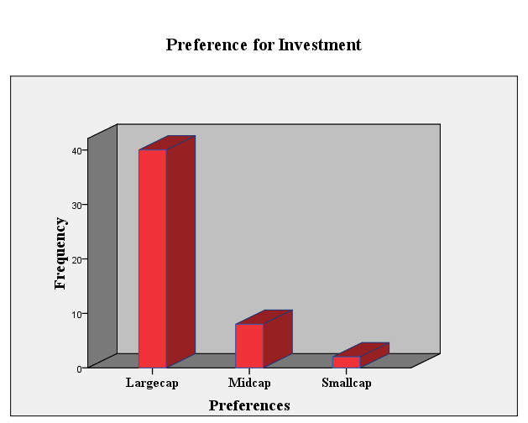

By seeing this we can say that people prefer to invest in largecap companies. It may be due to less risk.

14. INFLUENCING FACTORS

Factors | No. of respondents | Percentage
Transparency | 32 | 64%
Hassle Free Service | 07 | 14%
Economical | 06 | 12%
Time saving | 05 | 10%
Total | 50 | 100%

INFLUENCING FACTORS
64%
14%
12%
10%
Transparency
Hassle Free Service
Economical
Time saving

Out of the four fascinating factors of online share trading transparency is at the top as 64% people has voted for it followed by hassle free with 14%, economical with 12% and time saving with 10% respectively.

15. FUTURE PLANNING FOR ONLINE TRADING

Reply | No. of respondents | Percentage
Yes | 26 | 52%
No | 22 | 44%
Can’t say | 02 | 04%
Total | 50 | 100%

FUTURE PLANNING FOR ONLINE TRADING
52%
44%
4%
Yes
No
Can’t say
Percentage of people

Out of the total sample size 53% people are planning to go for online share trading and 43% people do not want to go for it while 4% people have not yet decided.

16. REASONS FOR NOT ENTERING INTO E-BROKING

Reasons | No. of respondents | Percentage
Relationship with broker | 27 | 54%
Trade rarely | 15 | 30%
Other reasons | 08 | 16%
Total | 50 | 100%

0%
10%
20%
30%
40%
50%
60%
Percentage of
People
Relationship
With broker
Trade rarely
Other reasons
REASONS FOR NOT ENTERING INTO E-BROKING

55% people do want to do online share trading because they have good relationship with there broker, 30% people trade rarely and 15% have some other reasons.

COMPARISION WITH COMPETITORS

According to me ICICI DIRECT and INDIA Infoline main competitor of The Edelweiss Ltd. And IL & FS is also in the race.

- ACCOUNT OPENING CHARGES:-Of all the brokers are close to the figure of Rs. 700-750 and if Edelweiss Ltd. has to win the race in the competition they have to lower down their accounting charges up to Rs. 650. The accounting charges of brokers are given below:

975
950
700
750
200
600
750
0
200
400
600
800
1000
1200
ICICI Direct
IL&FS
INDIA BULLS
Edelweiss
FORTIS
UTI
HDFC
Series1

- BROKERAGE CHARGES: Brokerage charges of the entire competitor are similar with the Edelweiss i.e. .50% except ICICI and HDFC that is charging .75%. So the strategy to compete with ICICI is to provide more service with the same brokerage. The chart of brokerage is given below:

Brokerage charges (in %)
0.75
0.5
0.5
0.5
0.5
0.5
0.75
0
0.1
0.2
0.3
0.4
0.5
0.6
0.7
0.8
ICICI Direct
IL&FS
Indiabulls
Edelweiss
Fortis
UTI
HDFC securities
Series1

- EXPOSURE: - Edelweiss exposure is 4 times which is equal to all the brokers except Fortis which is providing 8 times exposure limit which is highest in the market.

4
4
4
4
8
4
4
0
1
2
3
4
5
6
7
8
9
ICICI Direct
IL&FS
INDIA BULLS
Edelweiss

FORTIS
UTI
HDFC
Series1
Customer Satisfaction: - Customer is the king of market and every company is trying to satisfy their customers. Edelweiss is also doing same thing. And Edelweiss is the leader in satisfying the customers.

Customer Satisfaction (in %)
60%
78%
55%
80%
60%
70%
70%
0%
10%
20%
30%
40%
50%
60%
70%
80%
90%
ICICI Direct
IL&FS
Indiabulls
Edelweiss

5 paisa
UTI
HDFC securities
Series1

5. MARKET CAPITALISATION: - Market capitalization of the company is 11.70bn Rs. which is very less in comparison of other share trading service providers.

6. NUMBER OF EMPLOYEES: - No. of employees is also an important tool to compare the services of Edelweiss with the services of other companies. Because no. of employees shows the ability of the company to serve its services. Its also shows that how the company is able to satisfy their customers.

CHAPTER 6
FINDINGS

- It is found that people who were observed, they are yet investing in Insurance. And mutual funds are also a good option for them. Post office was 3rd favorable option for investing. It may be due to less knowledge of Share-market as well as it is considered risky.

- ICICI is found to be most popular among all. People are well aware of various services providers like edelweiss.com, kotakstreet.com, hdfcsecurities.com. Professionals and executive category are found to be in favor of the online share trading. They showed interest in going for online share trading.

- It is also seen that people think that online trading is convenient and easy to operate but they also need initial guidance and training. So it must be provided to them so that they can trade comfortably via online.

- According to most of the people observed NSE is better than BSE.

- People prefer to invest in large cap companies because of less risk.

- News and magazines are found to be of major source of information.
- 93% people found to be aware of online trading of securities.

- 43% people said that they have visited at least one of the website for the online share trading concept.

- 90% of the total population agrees that the concept is easy, convenient & interesting.

- Still only 53% people are sure to go for online share trading. 41% people rarely want to go for online trading.
.
- People have highly voted for transparency feature of the online trading followed by hassle free service, economical and time saving features.

- Business class prefer off line share trading as most of them have good relationship with their broker.

- Business class which can be defined as the people who are self employed entrepreneurs are found to be less interested and would like to stick to the traditional system and are much dependent on their broker regarding investments.

- The others which can be described as who are below 200000 incomes and which rarely trade in share. They are unwilling to go online as they cannot afford the service charges.

Findings After comparison with competitors:-

1. Investors mainly believe in classical trading i.e., they open an account with a broker, goes to him and purchase shares through him. They are not aware about online share trading account.
2. There is friendly environment for the investors. They can directly talk to branch manager or to the concerned persons. There is not any provision of appointment.
3. Edelweiss mainly focuses on customer satisfaction. That’s why they are the leader in the market in this area.
4. Edelweiss provides simple, easy and fast online stock trading. Buying and selling orders are executed very fast. So, an investor can trade there shares at the rate at which they want to trade.
5. It offers single window access of almost all financial products. Edelweiss provide almost all type of financial products so, an investor can minimize there risk by diversification of there investment.
6. Employees have liberty to express there views and organizations always welcome there suggestions. So, the employees can give any suggestion any time.
7. Increment to the employees is given on the basis of the work done by the each employee.
8. Employees can leave organization at any time at there will.
9. The best thing of the organization I found that they provide Demo for the online share trading to its investors. So, the investors can easily trade with the online share trading soft wares and also can understand about the market.
CONCLUSION
Shares are the best kind of investment available over a long period of time. And also share market is a place where money earns money. For investing in share market every investor need to have an agreement with a Depository Participants. Depository Participants are the one who provide the services of De-mat.
Edelweiss is very well known among the investors but from the analysis I found that ICICI Direct Securities is one of the major competitors. During my research I found that there is a large market which is untapped, as most of people find the concept of online share trading very interesting but none of them have been visited by the representative of any company.
During my research I also found that many people want to stick with the traditional system of share trading because of lack of computer knowledge and also many people are dependent of their personal broker. In the research I observed that Edelweiss limited is not effective in the advertisement of its products.

CHAPTER 7
SUGGESTIONS

1. Edelweiss charge Rs.750 while opening a Demat and trading account. Whereas, there are certain companies which provide same facility at lesser cost. So, to compete in the market Edelweiss should charge less or should give more benefits to the investors. In nut shell Edelweiss should provide better value proposition to its investors.
2. Edelweiss is one of the leading companies in customer satisfaction but, the customer base of Edelweiss is less in comparison of its competitors (ICICI). This is because of the awareness of the company. So, Edelweiss should create awareness among the investors to enhance the customer’s base.
3. To increase the market share it is necessary to provide the best customer care services. And quick response is also required to solve the customer’s problem.
4. Edelweiss charge 0.50% brokerage on delivery which is equal to that the other companies are charging. So, Edelweiss can reduce this brokerage to increase its customer base.
5. In India 70% investors invest only 10% of there income in equities. Edelweiss can maximize there profit by encouraging these investors to invest in the equity.
6. In Edelweiss employees can leave there organization at any time at there will. In present scenario employees are the assets of the company. So, company should adopt such policies which can retain its employees in the organization.
7. Client advisors should be trained and qualified. So, they can handle customers with more efficiency.
8. Company should also emphasis on its infrastructure. There should be more branches and more number of employees to improve the services of the company.
LIMITATIONS

There is no activity without limitations so it had too. The main Limitation has been faced during project research are as follows:-

- The research has been carried on time span of two months.
- Budget for research was limited.
- The research is totally based on the personal opinion of the respondents which may vary depending upon their personal view.
- The research has done along with achieving our target given by company.
- People’s response was also not favorable.
- Due to instability of market people were afraid of it , so they were less interested in these things.

CHAPTER 8

Appendix

QUESTIONNAIRE

Personal Information:

- Name:
2. Gender:
(a) Male (b)Female 3. Address:

4. Contact No.:

5. Age: (a) Between 20-22 years (b) Between 22-25years
(c) Between 25-30years (d) Above 30 years

6. Are you married? (a) Yes (b) No

7. Education: (a) Postgraduate (b) Graduate
(c) 12th (d) below 12th

8. Are you employed?
(a) Yes (b) No

9. What is your monthly income? (In Rs)
(a) Below 10000/-
(b) Between 10000-20000/-
(c) Between 20000-30000/-
(d) Above 30000/-

Research-Questions:

10. Which is the best investment-option for you?
(a)Bank (b) Insurance
(c)Post office (d) Mutual Funds
(e)Stock-market (g) Others

11. Do you have De-Mat A/C?
(a) Yes (b) No

12. If yes, which company’s de-mat a/c do you have?
(a)Edelweiss (b) Reliance
(c) Religare (d)India-Infoline
(e) ICICI (f) Others

13. Which is the best company according to you?
(a) Edelweiss (b) Reliance
(c) Religare (d) India-Info line
(e) ICICI (f) Others

14. Have you ever done Share-trading?
(a) Yes (b) No

15. Have you done Online-Trading?
(a) Yes (b) No

16. Do you agree that online trading is easy & convenient?
(a) Yes (b) No

17. Do you need training for online trading?
(a) Yes (b) No

18. Which options do you use?
(a)Intraday (b) Delivery
(c) Short sells (d) Margin trading
(e) All

19. Which is better according to you?
(a) NSE (b) BSE

20. Which is your preference for investing?
(a)Large-cap (b) Mid-cap
(c)Small-cap (d) All

21. Are you interested to open a de-mat a/c. with Edelweiss?
(a) Yes (b) No

BIBLIOGRAPHY

- PHILIP KOTLER (11th Edition)
Marketing Management
- C.R. KOTHARI (2nd Edition)
Research Methodology
- RAMA SWAMI
Research Design
COMPANY WEBSITES:-
- www.edelweiss.com
- www.nseindia.com
- www.google.com

