|  |  |
| --- | --- |
|  |  |
|  |  |

|  |
| --- |
| **[MEXICAN PESO CRISIS of 1994]** |
| Also known as the Tequila Crisis or December Mistake of Mexico |

**MEXICAN PESO CRISIS**

## 1 Mexico - Pre 1994

* 1982-1985, Mexico’s annual rate of inflation slowed from around 100 percent to about 65 percent as a result of government spending cuts and tighter monetary policy.
* Net transfers to the rest of the world totalled nearly 6 percent of GDP.
* The government could not work out credible anti-inflation policies and inflation could not be brought under stringent control as it accelerated in 1985, and spiralled 2 more than 100% a year by 1986.

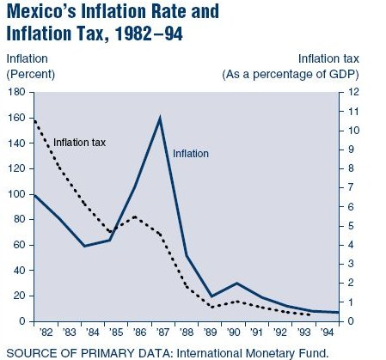

Although the economy was opening to trade, it was still relatively closed and the private sector was uncertain about the government’s true commitment to open markets. After an earthquake in 1985, another oil shock in 1986, and a stock market crash in 1987, Mexico was in dire need of effective economic reforms.

*Pacto*, a Pact for Economic Solidarity was designed by representatives of the labour, farming, and business sectors to control wages and prices.

2 Events leading to the 1994 Peso Crisis

### Political Scenario in 1993-94

* Election year

The Institutional Revolutionary Party (*Partido Revolucionario Institucional* or PRI) had been the ruling party in Mexico for about 70 years. During the administration of Mexican President Carlos Salinas (1988-94) ambitious market-oriented economic reforms were carried out that produced a significant reduction in inflation and the implementation of NAFTA. Salinas government launched the usual PRI spending spree, allowed cheap credit, and avoided making a much-needed correction in the exchange rate.

* Political turmoil -Rebellion in southern province of Chiapas

On January 1, 1994, in the southern Mexican state of Chiapas, hundreds of masked rebels who called themselves the Zapatista National Liberation Army rebelled against the Government fighting for their basic necessities. The armed uprising, only seven months before a presidential election, raised doubts about Mexico’s political stability and evoked fear among the foreign investors.

Assassination of Luis Donaldo Colosio

Presidential candidate of the ruling PRI, Luis Donaldo Colosio, was assassinated on March 23rd. The public saw Colosio as a harbinger of hope and change in the corrupt political system and Colosio’s death heightened fears of political instability and set off a brief financial panic that coincided with a sharp drop in Mexico’s international reserves. The sharp drop in Mexico’s international reserves from February to April 1994 reflects the loss of reserves, in about four weeks; Mexico lost nearly $11 billion in reserves.

Following Colosio’s assassination, the ruling party chose Ernesto Zedillo as its new presidential candidate. He won the presidential election by a solid margin.

**3** **Economic Factors around** **The Crisis**

**3.1 The fundamental macroeconomic variables surrounding the crisis:**

3.1.1 Large current account deficit: Though Mexico had a good fiscal position, it had a huge current account deficit during the early 1990s (The deficit had increased from $6 billion in 1989 more than $20 billion in 1992-93). The Mexican government was of the view that this was being caused by a private inflow of capital that was financing investment spending and not by fiscal deficits or excessive monetary expansion. *The "Pitchford Thesis" states that a current account deficit does not matter if it is driven by the private sector.* It indicated that the Mexico policy reforms were the stimulus behind the foreign capital inflow.

* + 1. Overvalued Peso:However, this led many to believe that Peso was becoming over-valued (i.e. the shadow exchange rate had moved above the pegged exchange rate). One major indicator for this was the rapid rise of consumer and producer price indices in early 1990s.
    2. Rise in Real Exchange rate: During the early 1990’s the Inflation rates in Mexico were consistently higher than that of USA. Therefore in real terms, the peso was actually appreciating, contributing to the increasing current account deficit.

Mexico did not show concern for Current Account deficit mainly because of its booming dollar reserves. They felt that since the GDP growth rate was robust for the past 6 years, there wasn’t a need for a major policy decision on the current account deficit. However, much of the capital investment in Mexico did not directly finance investment spending in development projects. Elections were fast approaching and the government was reluctant to make any major policy changes.

**3.2 Foreign Capital Inflow**

Purchase of government bonds was the largest form of foreign capital inflow and also the most risky one for Mexico. In 1990-94 period close to $43 billion alone came into Mexico for this. Major drivers behind this was Low interest rates of the US and the sterilization (discussed later) of Mexican Government.

Short term Treasury bills (3 months) in US were yielding not more than 3 to 4% in 1992-93, which lead to a lot people investing in Mexico and other developing countries in hopes of higher returns. Mostly money was invested in short-term, highly liquid treasury bills (maturing in one to three months) called cetes which yielded more than 15%. Since they were short-term, they posed less risk and were very attractive to investors. Also, investors could easily take out their money on maturity thereby putting tremendous pressure on the government’s reserves in a matter of weeks.

The more robust form of inflow, Foreign Direct Investment totaled $24 billion for the same 5 years, only a quarter of the total capital inflow. This type of investment is long-term because it involves commitments that cannot be reversed quickly at low cost. Mexico should have tried to attract more inflow through this route for investments in infrastructure and creation of physical assets.

This large capital inflow especially the one through the purchase of bonds gave the government a false sense of security. The government this way accumulated large FOREX reserves. To match this increase of government’s assets, they would have also had to increase the money supply (liabilities). To counter this so that it doesn’t lead to inflationary pressures, the government took certain policy decisions.

1. Constant Sterilization Intervention instead of devaluation:

* The government chose to use Sterlization instead of devaluation because elections were approaching
* The central bank matched its purchases of international reserves with sale of government bonds from its portfolio.
* Mexico’s central bank justified its sterilization of the inflows because without it monetary expansion would have led to inflationary pressures
* Not going for devaluations ensured credibility in the market and continued foreign inflow to depreciate to a point just below the top of the target band.
* Also, the Government followed the policy of managed peg in which the floor was kept constant while the ceiling was regularly increased to allow room for the peso
* The result of constant sterilization was that by November 1994 Mexico’s ratio of highly liquid government and bank liabilities increased to nine times the size of net international reserves, the highest in Latin America which put it in great risk (Joseph A. Whitt, Jr)
* Even many Mexicans were holding large amounts of cetes that could be shifted to dollars in a matter of days



1. Change in Government Debt Composition from Cetes to Tesobonos:
2. The government decided to convert a considerable portion of its peso-denominated securities into dollar-indexed securities called tesobonos. By November 1994, cetes had shrunk to only 25 percent while Tesobonos were 70%
3. By replacing maturing cetes with tesobonos, the government realized an immediate reduction in the interest cost of its debt because the interest rate on these indexed bonds was usually 6 to 8 percentage points below the rate on cetes
4. However, switching to tesobonos introduced a risk that if the government eventually chose to devalue, it would not benefit from a reduction in the real value of its dollar-indexed debt, as it would in the case of peso debt
5. Many economists believe they did this since there were many looming rumors of devaluation and this would enhance the credibility of maintaining the exchange rate bands.
6. **Dealing with the Crisis**

When Zedillo came in office on 1 December, 1994, Mexico was already on the verge of an impending crisis. With only $12.5bn in reserves and a debt structure flooded with short term securities. The current account deficit was over $20 bn. for the third year in a row, and the exchange rate had also risen to the top of its target band, leaving no room for further depreciation. At this time the Mexican economy seemed to be at a crossroads of options, with four options (Joseph A. Whitt, Jr) none particularly attractive:

1. One way would be to tighten the monetary policy by raising interest rates, and ending the sterilisation drive, this would help in reinforcing the peso. Though Barro(1995) argues that this would have helped in avoiding a December devaluation and eventually avoiding the crisis altogether, there is also a contrary view that a slow Mexican economy with an overvalued Peso and increasing interest rates would have saw right through the weak banking system in Mexico (Dornbusch and Werner, 1995).
2. Completely shifting to a floating Peso, this would have also eliminated the need to have forex reserves altogether. But as the Peso was currently overvalued, such a move would lead to peso depreciating considerably that might have resulted in an inflationary spiral.
3. Devalue the Peso. Though the new peg might help to retain public confidence, some feared that as the Govt. anyways had fewer reserves a new peg might make it more vulnerable to a speculator attack.
4. Another involved devaluing the currency using a Currency Board. A currency board is required to convert domestic money into international reserves at a fixed rate on demand. Here to fix the exchange rate, the monetary base must be backed fully by international reserves. But a typical limitation was that though it constrained the monetary authority it did not prevent other entities like private banks and authorities from getting into an illiquid position.

## The Financial Crisis

* The Colosio assassination brought in a long period of uncertainty along with falling reserves. This somewhat stabilized in April after Ernesto Zedillo settled in.
* The real challenge came up when the interest rates in US began to increase, in February 1994 the Fed decided to hike up interest rates. Several additional increases followed for both short term and long term interest rates while Mexico did not increase their own because elections were slated that year. This made a lot of capital to flow out of Mexico.
* To safeguard the economy against the fleeing forex reserves, the central bank of Mexico, purchased private sector securities at an interest rate lower than those demanded by the foreign investors. This attempt to sterilize the fall in international reserves proved to be incompatible with defense of the exchange rate peg. Thus, the monetary base went up and also ended pushing up the interest rates.
* However, Mexico had by now developed large debt because of its policies and majorly in the form of dollar-indexed tesobonos. Since, they were dollar-indexed; devaluation would not have helped Mexico reduce its debt.
* On December 20, the devaluation was announced, it increased the ceiling of the band leaving the floor unchanged. It also subsequently announced that it would continue to do the same i.e. raising the ceiling of the band at the rate of 4.5% per year. However, this did not cause any panic in the market and the sale of tesobonos went off smoothly that day.
* On December 21, the regular weekly auction of cetes also went well. However, the loss of governmental credibility led nervous investors to shift funds out of Mexico, resulting in a loss of $4.5 billion in central bank reserves, the largest single-day decline of the year.
* On the morning of December 22, with reserves now reduced to less than $6 billion, the government announced that it was abandoning the exchange rate target band and allowing the peso to float. In addition, it announced that it had arranged a credit of $7 billion with the United States and Canada.
* With this announcement the financial turmoil began, interest rates increased, the peso fell sharply, and the government’s access to credit markets dropped sharply. Almost overnight, Mexico lost its reputation for maintaining a stable exchange rate and sound financial policies.
* What Mexico suffered was from a Speculative attack, a self-fulfilling debt crisis in which when it became well known that the Mexican Government might not be able to meet its debts there was widespread panic, people converted massive amounts of Pesos into Dollars and fled the markets thereby eating up the severely depleted reserves and putting the Mexican economy into crisis.
* The huge difference between the severe market reaction to the move to a floating peso and the relatively mild response to the initial devaluation makes many critics say that Mexico might have been better off increasing the target band’s rate of crawl and making an earlier decision to devalue while reserves were still relatively high and it would have prevented the crisis that ensued.



**6 The Contagion Effect of the Tequila Crisis**

**6.1 The Brazilian Episode**

The widespread devaluation of the currency against the US dollar had acted as a virus in the global economy since the Mexican Crisis of 1994.

* Implement structural adjustments and economic reforms designed to satisfy the conditions set by the International Monetary Fund (IMF) for a $41.5 billion loan
* This would prevent a ‘run-on-reserves’ despite a ballooning current account deficit
* Cardoso failed to deliver- unable to get the IMF supported budget
* Feeling amongst investors that Brazil is going to find difficult to clear off its debt in much the similar manner as was the case with Mexico
* Brazilian Central Bank pushed up interest rates to nearly 50% to keep savings in Brazil-became more and more difficult to service both public and private service debt and thus investors became even more confident that a major default would eventually occur
* Announcement by Itamar Franco, a former president and current governor of Minas Gerais, that his state government would cease servicing the state's $15 billion debt to the federal government for ninety days
* Thus, the potential of default rose into the economic red zone and capital flight increased at a rate of over $ 2 billion per day
* This eventually led to devaluation

**6.2 The Argentine Angle**

* The Argentine economic policy of the 70s and the 80s was characterized by fiscal irresponsibility and repeated attempts to stabilize prices
* In 1989, inflation was around 38% and fiscal deficit around 20% of GDP
* ‘Convertibility Act’ was passed in 1991 which pegged the Argentine Peso to the U.S. Dollar
* Interest payments on debt fell by 16% of the GDP. Also under the Brady Plan, foreign debt was reduced by 9%
* The convertibility and stabilization scheme led to an initial boom from 1991 to 1994
  + Inflation fell from 12% levels to 0.4% in 1994
  + Boom in output and consumption
  + Huge trade imbalance due to increased consumption
  + GDP growth around 7.7% and imports rose by 40%
* Interest rates in U.S. were 3% in 1991. However a tightening of the monetary policy in early 1994 caused the rates to move upto 5.5%
* However a credit crunch owing to fleeing of foreign investors was only seen in the first quarter of 1995
* The timing of the Argentine crisis essentially proves that it was fuelled by the fear in the investors because of the Mexican Peso crisis
* Also at the time when there was a ‘run-on-reserves’ in Argentina its economic fundamentals were perfectly alright, again underlining the contagion effect of the Mexican crisis
* Thus a huge credit crunch ensued in March 1995 in Argentina and sunk into a recession

# 7 Bailout and Economic Performance since the Crisis

By January 1995, the situation was desperate and Mexico needed cash quickly to avoid defaults. The Mexican government realized that it could not succeed in fixing the crisis on its own so it sought help from foreign entities, primarily from U.S. commercial banks.

The Clinton administration proposed a direct-loan package that included $20 billion from the United States and $18 billion from the IMF (largest in IMF history) plus about $13 billion from the Bank for International Settlements and other commercial banks. The peso continued to weaken to 7.45 pesos per dollar, until Mexico announced a stringent austerity package in early March. After that, the peso strengthened significantly and in real terms remained stronger for the rest of 1995.

The bailout and reform package were highly effective. Between 1996 and 1999, GDP grew by more than 5% per year. In January of 1997, Mexico paid back the US$13.5 billion in loans from the US government ahead of schedule.

Mexico’s post crisis reforms came at a severe cost to the PRI. In 1997, the PRI lost control of the Mexican congress.Then in 2000, the PRI lost the presidency of Mexico for the first time in 70 years.

CURRENT SITUATION

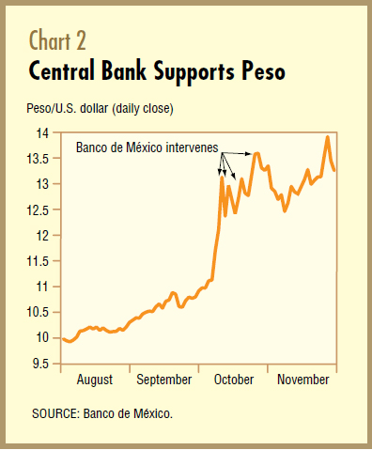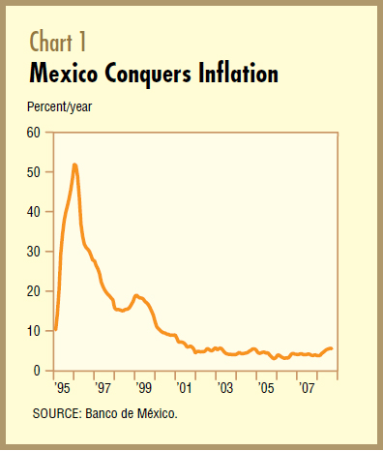Situation until 2007

* + The external share of total public debt has fallen from a high of 85 per cent before the Tequila Crisis to 40 per cent today. In 1995, Mexico’s longest bond had a maturity of one year. Today, the nation issues 30-year peso-denominated bonds.

**8 CURRENT SITUATION**

* The deterioration in the economy in 2009 during the first quarter was a reflection of the global financial crisis taking place and the recession in the US, Mexico’s chief export market and source of remittances, foreign direct investment and tourists. Another addition to this deteriorating growth in the second quarter, was the consequences of the swine flu outbreak
* The overall economic downturn in 2009 will surely be the worst since the economic crisis of the mid-1990s, which caused the economy to contract by 6.2% in 1995. The collapse in US demand will continue to hit manufacturing hard, triggering a rise in unemployment. Tougher access to credit will undermine private investment. Private consumption will also be further damaged by falling overseas workers' remittances, weaker credit expansion and negative real wage growth.

**Steps taken by the Mexican Government**

The sharp increase in investment expenditure as part of the government's countercyclical efforts will continue, mitigating the contraction in fixed investment, but with exporters cutting capacity, inward foreign direct investment (FDI) falling sharply and credit conditions very tight (restricting private-sector participation in the government's infrastructure programme), overall investment will still fall sharply.

The biggest external shock in decades is causing analysts to forecast only a slowdown in growth rather than utter collapse, demonstrating how far Mexico has come over the past two decades.

**References**

1. Nora Lustig ,*The Mexican Peso Crisis: the Foreseeable and the Surprise*, Brookings Institution, June 1995
2. David J. McKenzie, *The Consumer Response to the Mexican Peso Crisis*, Development Research Group, The World Bank, Revised March 2006
3. Jared Kotler, Petra SipeYvonne Sui, *The Mexican Peso Crisis:View from the Mexican Government*, May 4, 2006
4. Joseph A. Whitt, Jr ,*The Mexican Peso Crisis*
5. NBER.ORG ( Mexican peso Crisis : How Much Did We Know, Sebastian Edwards, Working Paper)
6. Stephany Griffith Jones, *Causes and Lessons of Mexican Crisis*, World Institute for Development Economics Research, The United Nations, University,May 1997